Dear Neighbour,

There have been some successful playing out sessions on our street now and we want to thank you for your co-operation and help. We hope the sessions are welcoming, whether you have children or not.

We also want to remind everyone of a couple of points to make sure the sessions stay safe and enjoyable.

Parents are responsible for their own children at all times. The volunteer stewards will do their best to make the space safe and ensure younger children stay within the closure area but are not responsible for looking after unaccompanied children. If you let your children play out on their own, please be sure they are aware of this and are fully capable of looking after themselves.

Car drivers must alert a steward if they want to drive in or out of the street. The stewards will make sure everyone is on the pavement and will walk in front of the car to make sure everyone is safe.

Stewards are key to the success of these sessions and cannot happen unless we know they are in place. Do let us know if you are able to help out with this, or if you have any comments on how things are going. To find out more about the project go to www.playingout.net

Many thanks (name / email / phone?)

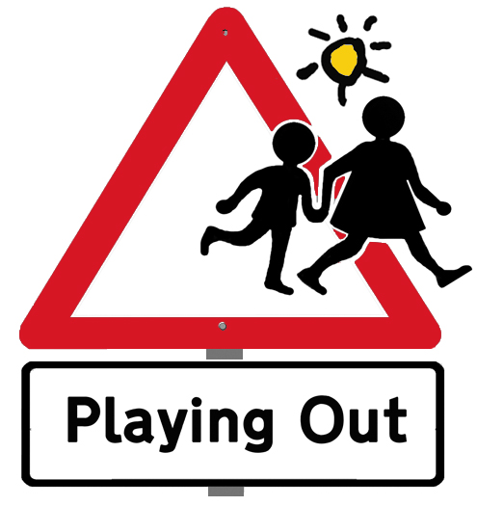
Dear Neighbour,

There have been some successful playing out sessions on our street now and we want to thank you for your co-operation and help. We hope the sessions are welcoming, whether you have children or not.

We also want to remind everyone of a couple of points to make sure the sessions stay safe and enjoyable.

Parents are responsible for their own children at all times. The volunteer stewards will do their best to make the space safe and ensure younger children stay within the closure area but are not responsible for looking after unaccompanied children. If you let your children play out on their own, please be sure they are aware of this and are fully capable of looking after themselves.

Car drivers must alert a steward if they want to drive in or out of the street. The stewards will make sure everyone is on the pavement and will walk in front of the car to make sure everyone is safe.

Stewards are key to the success of these sessions and cannot happen unless we know they are in place. Do let us know if you are able to help out with this, or if you have any comments on how things are going. To find out more about the project go to www.playingout.net

Many thanks (name / email / phone?)

