Dear neighbours,

We are writing to let you know that following a meeting [on xx date], we are in the process of applying for a Temporary Play Street Order.

Playing Out sessions are short, stewarded road closures, giving children the chance to play safely near home and making the street feel safer and friendlier for everyone. Parents will be responsible for their own children as normal.

We want to reassure you that this is not going to stop you from having car access to your house. Through traffic will be diverted but anyone wanting to park on the street will be asked to drive in and out at walking speed, escorted by a volunteer steward from the street.

The closure(s) is/are planned for: [dates & times here or overleaf]

We really hope you like the idea but please do talk to us if you have any questions or concerns. The council contact is:

Please let us know if you would be able to help with stewarding, as this role is crucial to the success and safety of the sessions.

Best wishes, [insert name and contact details]

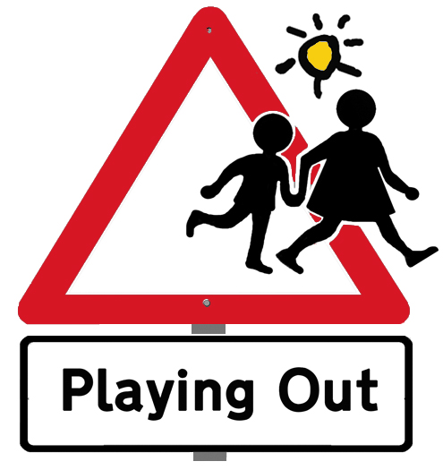

www.playingout.net
© Playing Out CIC 2010-2018

www.playingout.net
© Playing Out CIC 2010-2018

Dear neighbours,

We are writing to let you know that following a meeting [on xx date], we are in the process of applying for a Temporary Play Street Order.

Playing Out sessions are short, stewarded road closures, giving children the chance to play safely near home and making the street feel safer and friendlier for everyone. Parents will be responsible for their own children as normal.

We want to reassure you that this is not going to stop you from having car access to your house. Through traffic will be diverted but anyone wanting to park on the street will be asked to drive in and out at walking speed, escorted by a volunteer steward from the street.

The closure(s) is/are planned for: [dates & times here or overleaf]

We really hope you like the idea but please do talk to us if you have any questions or concerns. The council contact is:

Please let us know if you would be able to help with stewarding, as this role is crucial to the success and safety of the sessions.

Best wishes, [insert name and contact details]

